**Project Charter**

**Hashing Service**

**Date 5/18**

# PROJECT STATEMENT

Discuss the problem or opportunity that is scheduled for resolution.

The problem that my group is trying to solve is a reliable Hashing service that is easy to use and can be applied to man different applications such as passwords. Databases, and other services.

# CONCISE PROJECT OVERVIEW

A short narrative on the duration, budget, approvals needed, key stakeholders, assumptions, constraints and major risks.

The Duration of this project will be from 5/22/2023 - 6/2/2023 The key stakeholders of this project is my dad and MJV. The assumption is that this product is to provide a benefit on a wide range of applications. The main constraints for this project would be he limits of our coding ability. Aside from that, this product should turn out for the better. There are no major risks associated with the project and the budget for this product is 0$

# SCOPE STATEMENT

The product needs to be very reliable only verifying the correct password. This project will have a small scope as it is being primarily designed for just a couple of users. We hope in this limited amount of time to create a hashing service that will work for the desired small group of users without any issues.

# STAKEHOLDERS

The stakeholders in this project will be the users, Manan and Arhat’s dad and the developers who have been entrusted to make sure the product is functioning.

# TIMELINE

<https://docs.google.com/spreadsheets/d/1Fwg4Ukr0Z0BpE5kV6UxO3qzR5mMDzrSt/edit?usp=sharing&ouid=117941922376302675470&rtpof=true&sd=true>

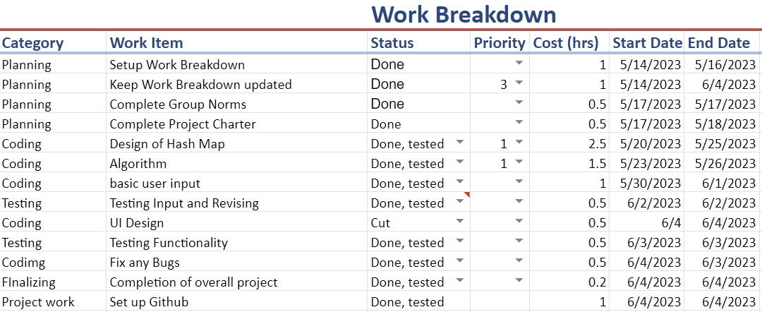

Draw a timeline, including milestones to serve as the basis for a work breakdown structure (WBS) and appropriate Gantt or PERT charts. For this class, you can refer to the Work Breakdown Excel Sheet.

# BUDGET ESTIMATE(S)

The project must be completed by June 5th at 8 am. This will take about 10 hours and will have no financial cost.

# RISKS AND CONTINGENCY PLANS

There are not any risks with the project itself but there are risks with unexpected circumstances such as sickness that may affect productivity. In order to get around this both members will maintain communication and adjust plans if needed to make sure the project is finished on time